ASP.NET Core 8 Minimal API Lab Manual

Lab Title
From HTML to Service: Building a Bilingual Greeting App with ASP.NET Core 8 Minimal API

Learning Objectives
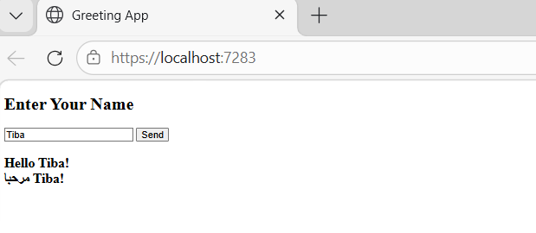
- Understand the role of Program.cs
- Create and register services
- Implement an interface with multiple implementations
- Use Dependency Injection
- Serve static HTML files
- Send requests from HTML to a Minimal API
- Return JSON responses
- Understand client–server communication

Project Story
We are building a simple web application:
1. The user enters their name in a web page.
2. The browser sends the name to the server.
3. The server generates English and Arabic greetings using services.
4. The server returns JSON.
5. The browser displays both greetings.

Final Program.cs
var builder = WebApplication.CreateBuilder(args);
builder.Services.AddScoped<EnglishGreetingService>();
builder.Services.AddScoped<ArabicGreetingService>();
var app = builder.Build();
app.UseDefaultFiles();
app.UseStaticFiles();
app.MapGet("/greet",
(string name, EnglishGreetingService english, ArabicGreetingService arabic) =>
{
var enMessage = english.Greet(name);
var arMessage = arabic.Greet(name);
return new
{
English = enMessage,
Arabic = arMessage
};
});
app.Run();
public interface IGreetingService
{
string Greet(string name);
}
public class EnglishGreetingService : IGreetingService
{
public string Greet(string name)
{
return $"Hello {name}!";
}
}
public class ArabicGreetingService : IGreetingService
{
public string Greet(string name)
{
return $"مرحبا {name}!";
}
}

HTML File (wwwroot/index.html)
<!DOCTYPE html>
<html>
<head>
<title>Greeting App</title>
</head>
<body>
<h2>Enter Your Name</h2>
<input type="text" id="nameInput" placeholder="Your name">
<button onclick="sendName()">Get Greeting</button>
<h3 id="result"></h3>
<script>
async function sendName() {
const name = document.getElementById("nameInput").value;
const response = await fetch("/greet?name=" + name);
const data = await response.json();
document.getElementById("result").innerHTML =
data.English + "<br>" + data.Arabic;
}
</script>
</body>
</html>

Student Task
Add a new service that calculates the length of the name.
1. Create an interface for name length.
2. Implement the service.
3. Register it.
4. Inject it into the endpoint.
5. Return the name length in JSON.
6. Display it in HTML.

